CAVE SPRINGS CAMP
School Overnight Packing List

ITEMS TO PACK
- T-Shirts, Shorts, Pants, Sweaters
- Bathing Suit, Pool Towel
- Socks, Underwear, Pajamas
- Sleeping Bag, Pillow (extra blanket)
- Hat, Sunscreen
- Insect Repellent (non-aerosol)
- Running Shoes, Extra Pair of Shoes (or hiking boots), Sandals
- Toiletries
- Raingear/Jacket
- Reusable Water-Bottle
- Flashlight (and batteries)
- Please do not bring knives, money or anything expensive that could get broken or lost
- We don’t recommend bringing electronics or a cell phone because camp is a place to take a break from technology
- Please note that we are not responsible for lost items.

FOOD
- Bring a bagged lunch for the first day. Please note that Cave Springs strives to be free of nuts and therefore, we ask students to bring nut-free lunches.
- Cave Springs will provide the meals for the reminder of the field trip
- Students are not required to bring any food or snacks, but if they do, we recommend eating them on the first day r storing them in closed bag so they don’t attract insects or critters
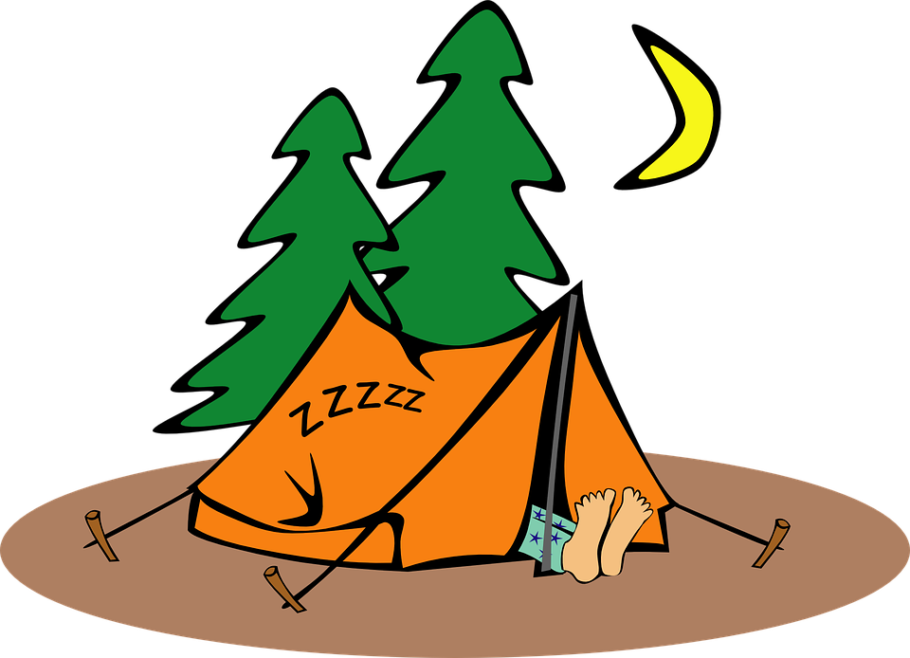

Cave Springs Camp
Cave Springs Camp, 4410 Cave Spring Rd, Lincoln, Ontario, L3J OW3

